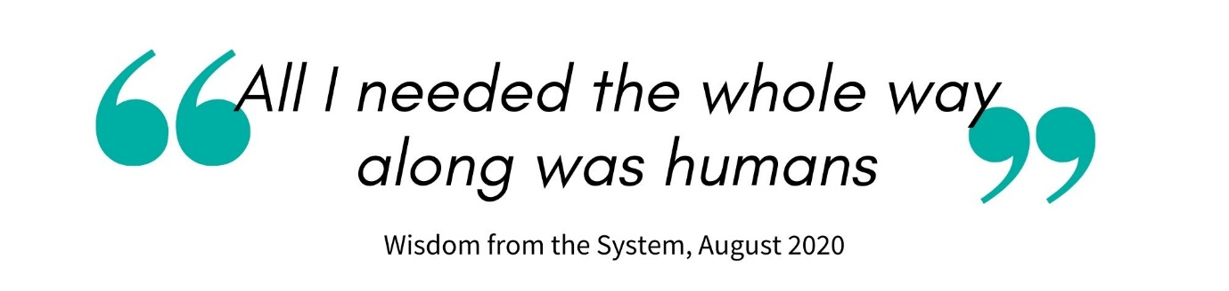
Are you someone ready to treat people as people and bring yourself to work?
Thank you for your interest in Mayday. In applying to work with us we hope that you will take the time to read our website, some of our blogs, and really make sure that you are up for the challenge of pursuing system change. We are an organisation of independent free thinkers, brave enough to challenge and be challenged, passionate about what we do and united to achieve an ambitious mission. If this excites you then we want to get to know you too.
https://maydaytrust.org.uk/
Application
There are two parts to complete:
Section One
This section is seen by the central team and not shared with anyone conducting interviews. It includes essential information such as how to contact you.
Mayday takes its safeguarding responsibilities seriously. We also recognise and try to tackle discrimination, racism and oppression, so this section also asks standard questions to help us with safer recruitment and to allow us to monitor who applies to us in order that we may target our recruitment campaigns to underrepresented people and communities.
Section Two
This is your opportunity to tell us about you, what you can bring to Mayday and what motivates you. Please be brief – there is no need to write an essay.
We respect the time that it takes to complete our application. We also realise that not everyone is good at completing ‘forms’, so if you would prefer to use an alternative method to respond to section two, such as a blog or a video, then please don’t hesitate. We would love it!
Next steps
Please submit your application by [date] by email to recruitment@maydaytrust.org.uk
A virtual assessment day using either Zoom or Microsoft Teams will be held on [date]
Individual interviews, also via Zoom or Teams, will be held on [date]

Application Form - Section one
Contact details
Name:
Address:

Email:
Telephone/mobile:

Equal opportunities monitoring. We would be grateful if you choose to share this information with us in order that we can ensure that information about our vacancies is reaching everyone. So that you don’t have to squeeze yourself into pre-defined boxes we have left space for you to describe yourself in your own way.
Gender:
Ethnic origin:
Sexuality:
Age:

All posts at Mayday Trust are dependent upon the legal ability to work in the UK. Successful applicants will be also be asked to provide details for two references, one of whom should be your most recent employer, or equivalent.
For more information on how we use the information you provide please see our privacy notice https://maydaytrust.org.uk/privacy-policy/

Safeguarding and rehabilitation of offenders:
All posts within Mayday Trust are exempt from the Rehabilitation of Offenders Act. Having a criminal record will not necessarily bar you from working with us; this will depend on the nature of the position and the circumstances and background of your offences. Depending on the role, successful applicants may be asked to complete a Disclosure and Barring Application.
Have you ever been barred from working with children or adults: yes/no
If there are any anomalies in your career and education history, such as unexplained gaps, please take this opportunity to explain them here. We support people who take time out, so if you have taken time to look after yourself or others then we will not discriminate against you.

Please either enclose an up to date CV or complete the sections on education and employment below. There is no need to do both. Please work backwards for a period of no less than 20 years or until you left school.
Dates | Organisation (if applicable)  Employer; College; Other | Activity  Job/voluntary role; educational course; Other activity

Relevant Qualifications:

Where did you hear about Mayday and this job vacancy?

Application Form - Section Two
Name:

Please tell us about your learning, how you learn, and any education that you may have attended. How that has helped you in work or life? Let us know how you continually self-develop.

Please tell us about your work history and what you have experienced and learnt which is relevant to this position.

Tell us about one thing that puts fire in your belly. What are you passionate about?

Ok, now we would like to know why Mayday, why this job, and how you would contribute to achieving Mayday’s mission.

